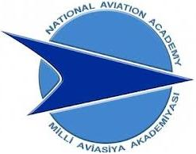

**“AZƏRBAYCAN HAVA YOLLARI” CJSC NATIONAL AVIATION ACADEMY**

**Individual Work № 10:**

**Topic: Leetcode**

**Subject: Obyektyönümlü proqramlaşdırma**

**Teacher: Mehemmed Shahmaliyev**

**Group: 1459i Student: Hesenova Firuze**

**Date: Signature:H.F**

**Baku 2022**

**Problem:Check age of driver.**

**print('Welcome to Tesla ')**

**def checkDriveAge():**

**age = input('How old are you ?')**

**if int(age)<18:**

**print('Sorry you are not allowed to drive.Powering off. ')**

**elif int(age)>=18:**

**print('Hi enjoy the ride.Powering on! ')**

**checkDriveAge()**